

Retail Customer Retention Analytics - Target
  - Power Bi Project
Nandini More | Power BI | 02/10/2025

Task 1
  - Data Modelling and Cleaning
- Load and Transform datasets in Power Query:
Loaded all the csv files in Power Query which was opened using Load and Transform data in Power BI.
- Handle duplicates, missing values and ensure correct data types:
Checked for duplicate and missing values using Remove Rows option in transform tab of Power Query.
Ensured correct data types for each column of each table.
- Create calculated columns:
Created ‘Membership_Duration’ column using DAX Calculated column function, used the inbuilt function YEAR to extract years. Calculated it in years due to further requirements in Task 6.
Extracted ‘Transaction_Year’ and ‘Transaction_Month’ in Customer_Transactions’ table using the Date function in New Column tab of Power Query.
- Create a basic Data Model View:
Created relationships between the tables in the Model View of Power BI.

Task 2
  - churn and retention metrics
- Create Churn Rate KPI :
- Created a Churn Rate KPI to find the trend using the Last Purchase Month between the Current Churn Rate and Target Churn Rate.
- It is a negative turning to positive KPI as a lower churn rate means we are succeeding in retaining the customers we have.
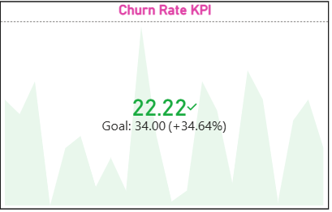

- Visualize Churn Rate by:
- Region :
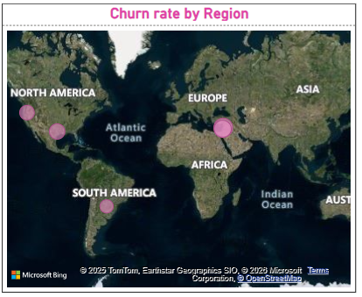

- Income Group:
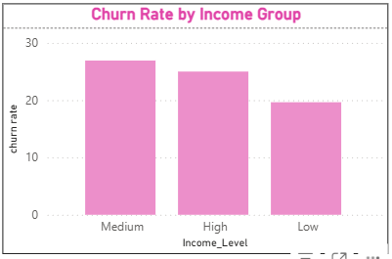

- Channel (Store/Online):
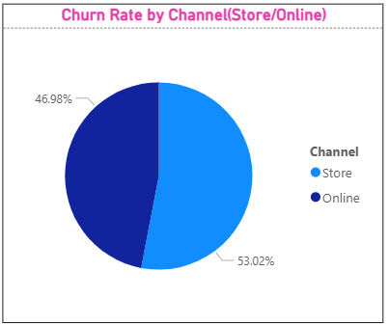

- Loyalty Tier:
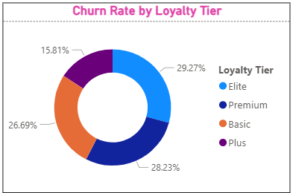

- Funnel Chart:
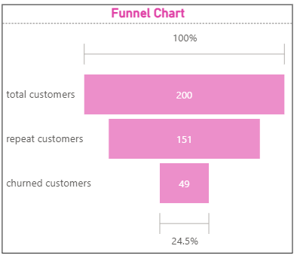

Task 3
  - repeat purchase analysis
- Segment Customers into tiers:
- Segmented customers based on their purchase quantity using Power Query.
- First applied a group by on Customer_Transactions table and then merged the group by with the original Customer_Transactions table to get the desired output.
- Average Purchase Frequency:
- Region:
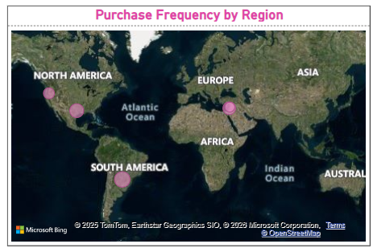

- Age Group:
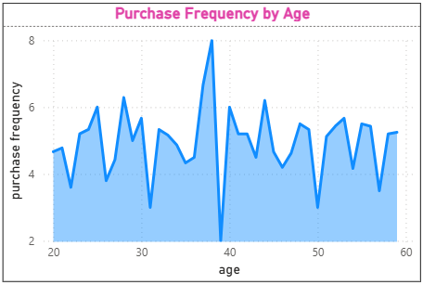

- Loyalty Tier:
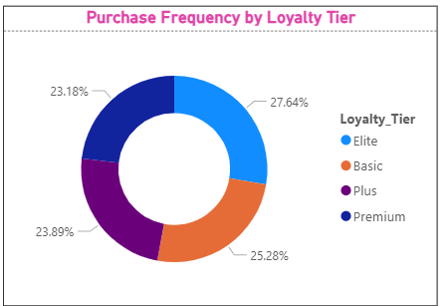

- Most purchased Product Category by Loyal Customers:
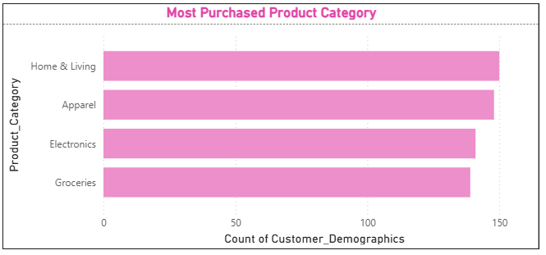
According to the above visual it is clearly seen that the most purchased product category is Home and Living with Apparel being a close second.

Task 4
  - promotion and loyalty impact
- Percent of Transactions with Promotion Applied:
- Average Purchase amount with vs without Promotions:
- Churn Rate across Loyalty Tiers:
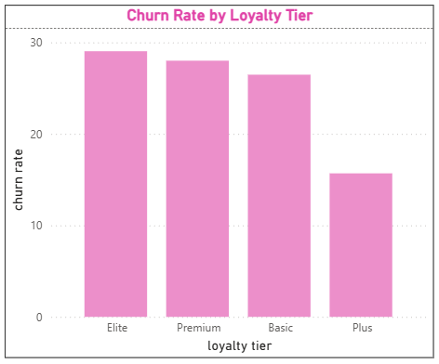
As we can see in the above Column Chart, Loyalty Tier has almost negligible impact on retention of customers, as the members with in Elite Tier have a higher Churn Rate than others.

- Points Earned vs Redeemed by Tier:
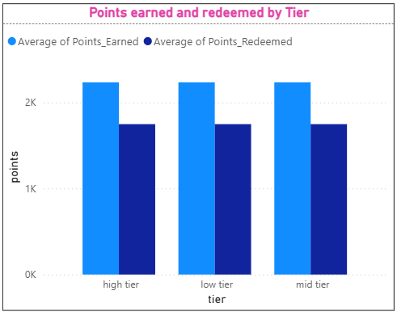

- Recommendations to improve redemption and retention:
- An entire re-evaluation of the Loyalty Tier should be done as we can see, customers highest on the Loyalty Tier are also high on the Churn rate.
- Earning and redeeming points is a good strategy and should be kept as it is after the re-evaluation of the Loyalty Tier, as it keeps customers coming back to redeem the points they have earned.
- A heavy campaign for the system regarding Promotions and Points should be done, as there is a significant difference in the prices and not many people are able to get the benefits of promotions.

Task 5
  - Store and channel performance vs retention
- Merge Store data with Transactions:
Merged both the tables using Merge Query in Power Query, added columns Store_Type, Region, and Opening_Year to Customer_Transactions for further visualization and analysis.

- Visualize:
- Average transaction amount by Store Type:
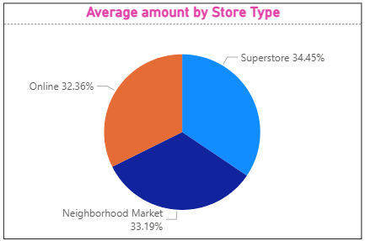

- Churn Rate by Store Type:
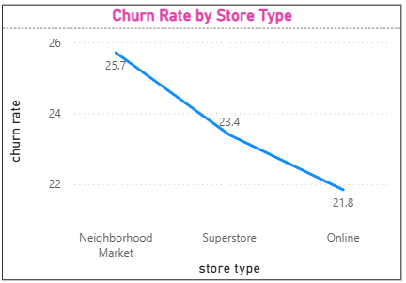

- Correlation between Store Opening Year and Retention:
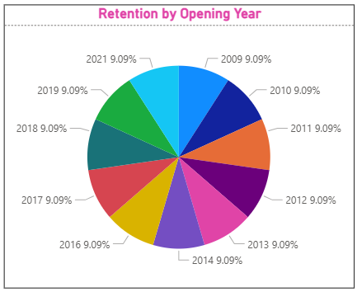
As we can clearly see in the above Pie Chart, there is zero correlation between the Store Opening Year and Retention of Customers i.e. Repeat Customers.
I have taken Repeat Customers as the defining value as it appropriately measures the Retention factor, we talk about in this study – meaning how many customers we can keep.

Task 6
  - Customer lifetime value(clv) analysis
- Calculating CLV:
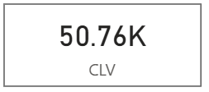
We are calculating CLV of each customer individually, so that we understand which customers to focus more on.
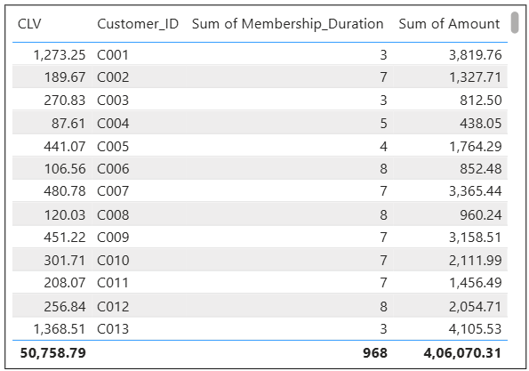
- Segment Customers into High and Low CLV:

Individually dividing customers into High CLV and Low CLV
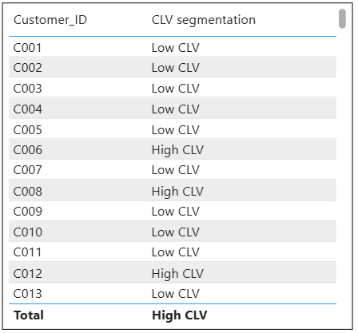

- Visualize:
- CLV vs Days Since Last Purchase:
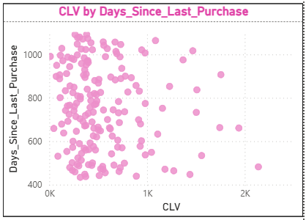
The scatter plot shows that while most customers are low value and inactive, there exists a smaller but critical segment of high-CLV customers who have not purchased recently and are therefore at high risk of churn.

- CLV by Loyalty Tier:
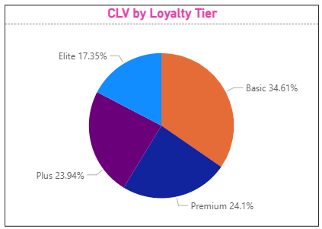

- CLV by Region:
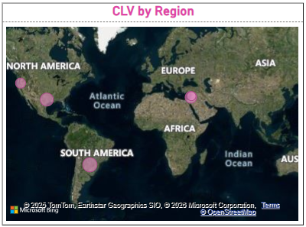

Task 7
  - FInal dashboard and executive summary

  - Page 1: KPIs

  - 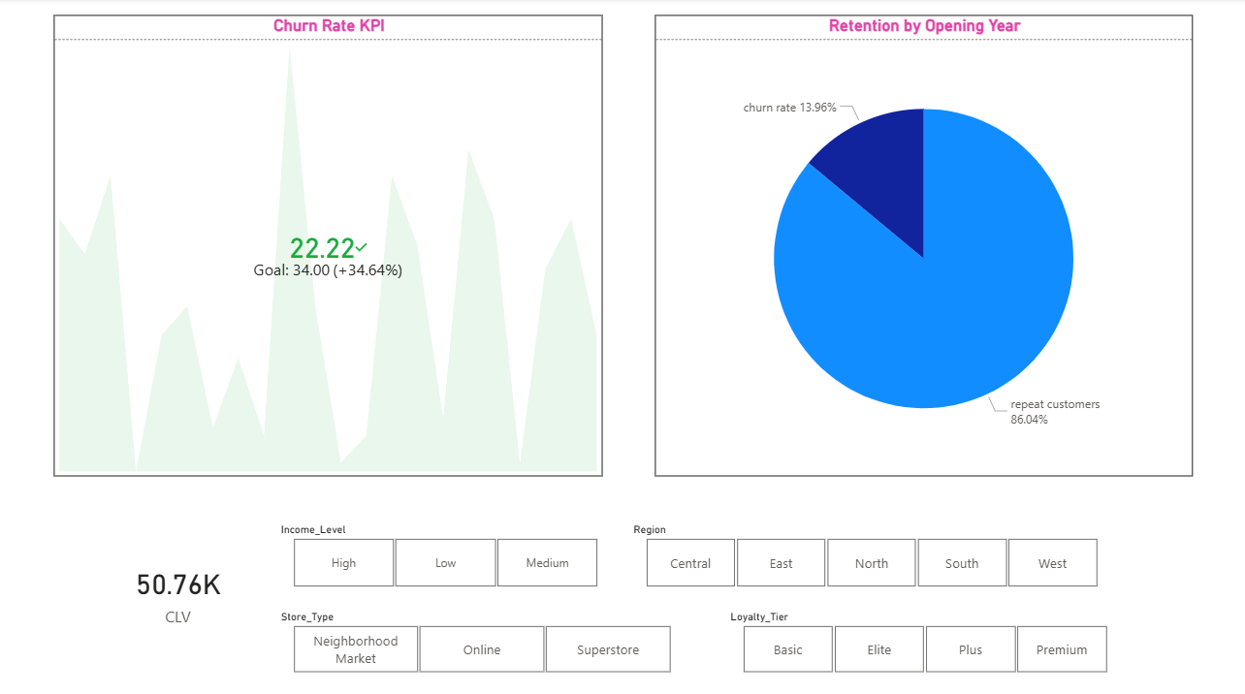

  - Page 2: Loyalty & promotion impact

  - 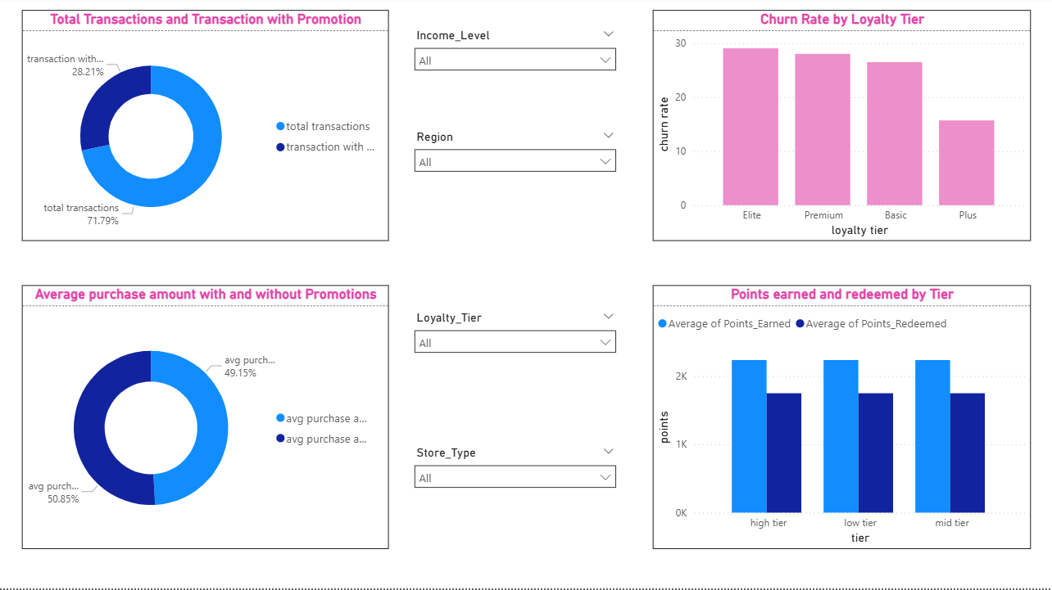

  - page 3: Store insights

  - 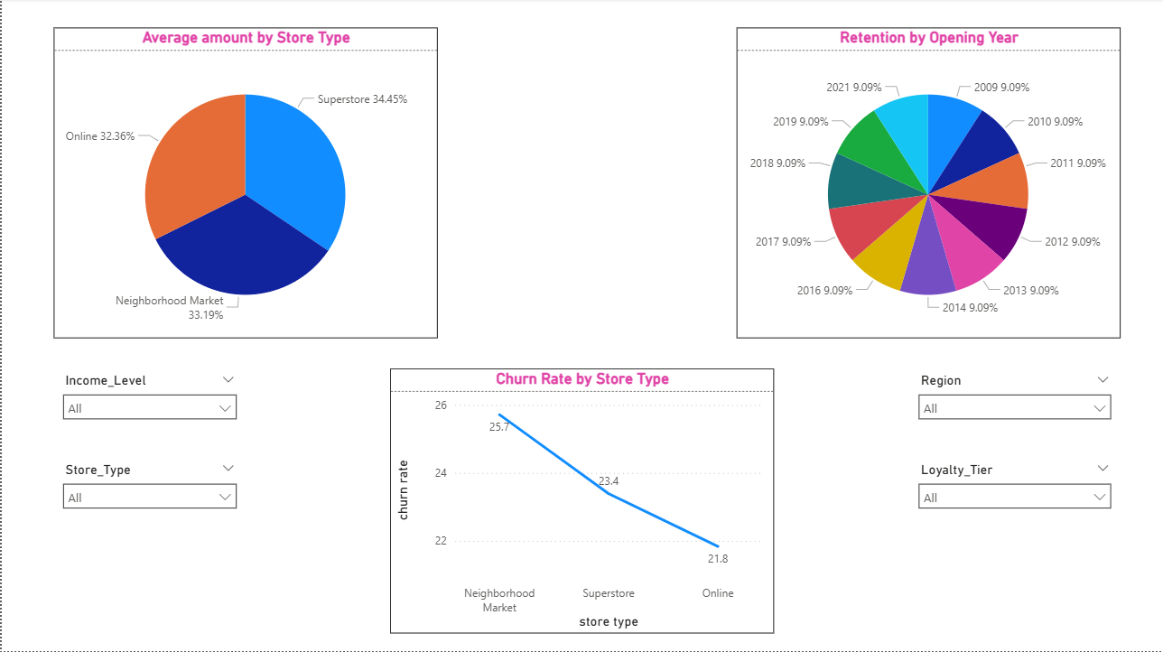

  - page 4: segmentation

  - 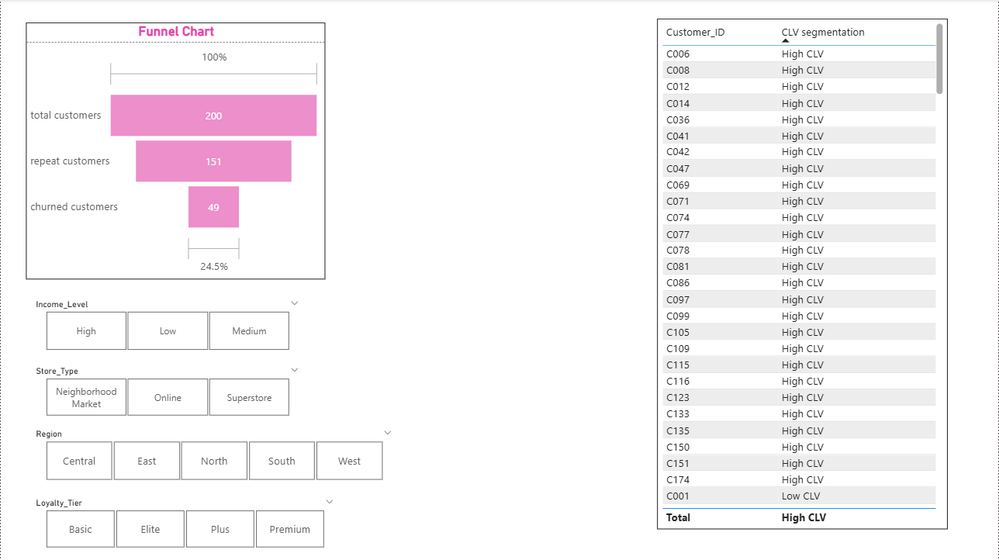
- Recommendations for Target:
Which customers to prioritize for retention?
The customers who currently have high CLV and are repeat/loyal customers with a high purchase frequency should be prioritized for retention first.
The second group are Loyal Customers who have been showing signs of churning, prioritize them by giving them additional benefits such as promotions and points to redeem to keep them from churning.
Which channels are underperforming?
According to these visuals,
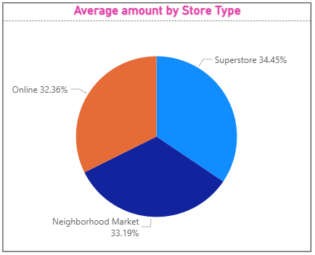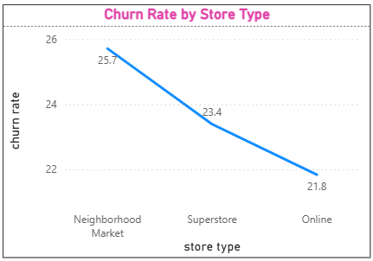
Neighborhood markets have the highest Churn Rate whereas Online Stores have the lowest average amount, so to deal with this neighborhood markets should start implementing more schemes, like discounts, promotions and loyalty programs and there should be more availability and expansion of Online stores so the revenue is increased.

How to strengthen Loyalty and Engagement?
First of all, an entire re-evaluation of the Loyalty System should be done, as we can see in this visual – Loyal customers have a high churn rate, identifying and dealing with why this is happening is of utmost importance.
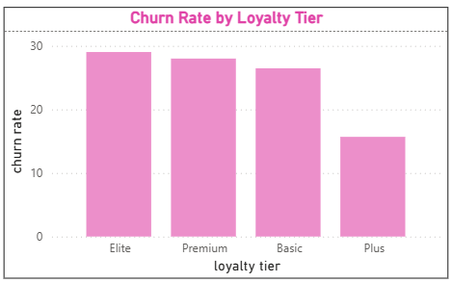
Promotions and their awareness should be increased as we can see transactions with promotions are quite low which harms our customer retention in the long term.

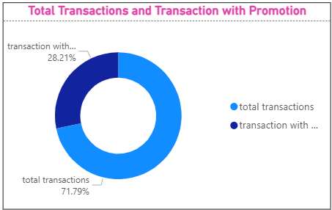
Also point redeeming is a very successful scheme as it keeps customers coming back for repeat purchases and makes them feel valued.
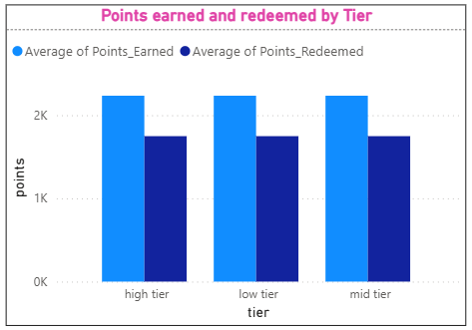

Task 8
  - Video explanation
Video Link - https://drive.google.com/file/d/1pHtHPJNQ2e4N90tNEHGl94856y4gDZbW/view?usp=drive_link

  - 

THANK-YOU,
NANDINI MORE

